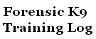
Date:___________________

Location:____________________________ Time In:_____________ Time Out:_____________

Handler:____________________________ K9:__________________

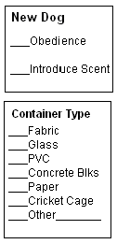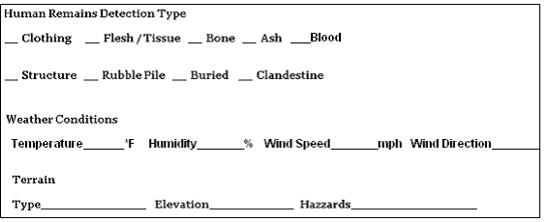

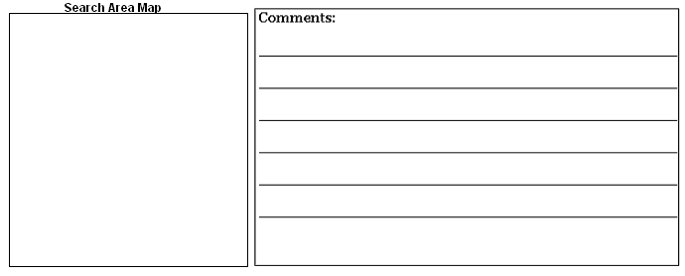 ___Narrative On Reverse Side
Starting Coordinates (NAD27):____________________ ____________________

Ending Coordinates (NAD27): ____________________ ____________________

Handler’s Signature________________________________________________

